TIME SERIES DATA ANALYSIS AND FORECAST METHODS

Lecture 7
Time series forecast

Yekaterinburg
2017
Contents

Lecture purpose 3

Lecture map 3

Part 1. Time series forecast definition 4

Part 2. Simple forecast with extrapolation 6
2.1. Forecast of mean absolute gain 7
2.2. Forecast of mean expansion factor 7

Part 3. Time series trend / tendency forecast 8

Part 4. Estimated accuracy and quality of forecast 11
4.1. Analytical indicators of accuracy 12
4.2. Comparative and qualitative accuracy indicators 14

References 16

Lecture purpose
The purpose of this lecture is to form concepts and skills in the field of forecasting of time series, studying of basic means of extrapolation and forecasts on the basis of regression models, and also acquisition of skills and abilities in assessment of accuracy figures of the forecast and its quality of fit.

Lecture map

- Time series forecast definition
- Classification of forecasts
- Examples of simple forecasts
- Extrapolation of trend and tendencies
- Regression methods of trend forecast
- Estimated accuracy of forecast
- Estimated quality of forecast from formal features

Part 1. Time series forecast definition
Forecasting − scientific based on the established causes and effect relationships and patterns of the studied time series calculation of a status and probabilistic ways of development of the phenomena and processes which are the cornerstone of time series.
When forecasting we try on those properties, characteristics and statuses of TS that were received during its analysis, to describe and give the characteristic of processes and the phenomena in the future. Most often forecasts classified by time of anticipation of future events: short-term, mid-term and long-term forecasts.
Short-term forecasts predict an initial time series on 2-3 observations forward. That is, if it was a number of average monthly numbers, for it the forecast for 2-3 months will be considered as the short-term forecast if a row contained annual values, the short-term forecast will be of 2-3 years. That is "urgency" of the forecast is always defined by its period. Mid-term forecasts usually predict a row for one season or one cycle forward, that is depending on an inner pattern of data this interval can change. Long-term forecasts usually predict values of data for several cycles/seasons, or on one cycle having the largest time period.
The general prediction algorithm of TS can be consolidated in several stages: analysis of an initial time series of forecasting, choice of a forecasting method, creation of an initial forecast model, its implementation and check of reliability, accuracy and justification of the forecast. In general the scheme of this algorithm is provided on the figure 7.1.

TS analysis
Choice of
forecast method
Creation of forecast model
Implementation of forecast model
Check of reliability of the forecast
Check оf accuracy and quality оf fit

Figure 7.1 – Flowchart of the general algorithm for the forecast phases

The easiest way of forecasting of a point set in general is extrapolation process. It is necessary to understand prolongation of the tendencies and patterns recorded in the past and the present on to future values as extrapolation. Here we describe four simple methods: the forecast at invariable levels of data, a method of the mean level of data, a method of a pure gain and a method of average growth rate.

Part 2. Simple forecast with extrapolation
The simplest forecast is the assumption that in TS the previous average levels do not change at all. Such forecast on M steps forward will look as:
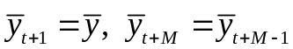 (7.1)
that is we will just continue the line of expectation values. It is clear, that such forecast can hardly be considered difficult, but in the short term sometimes even such forecast will be necessary for initial approach.
When forecasting on the basis of the average level, expression (7.1) опять it is again used for creation of the forecast, but now we also evaluate forecast accuracy by means of a concept of a confidence interval. The interval is called confidence if it is possible with in advance selected probability to claim that it contains value of the predicted indicator. The confidential interval forms two borders: upper 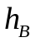 and lower 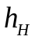.
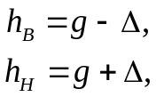 (7.2)
where 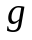 – estimated average forecast,  – a confidence interval.
For a method of the average level, the forecast taking into account a confidential interval is evaluated rather simply:
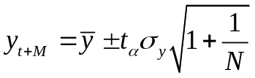 (7.3)
where 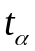 – value of t-Student statistic, 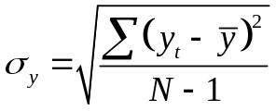, N – length оf TS.

2.1. Forecast of mean absolute gain
With forecast of mean absolute gain, the following technique is used:
- Pure gains are estimated 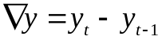. They have to be approximately identical.
- The inequalities 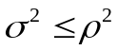 are checked, where 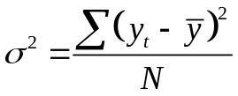 and 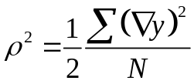.
- If checks are carried out, then the forecast model looks as:
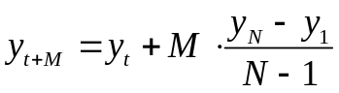 (7.4)

2.2. Forecast of mean expansion factor
With forecast of mean expansion factor (or average growth rate), the equation is used:
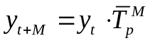 (7.5)
where 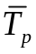 – the average growth rate or mean expansion factor, estimated as 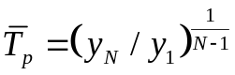.
This method is applied if growth rates are not additive, but chain, that is remain approximately identical, but at the same time the tendency of development of a row submits to geometrical progression and can be described by a demonstrative curve. In other words, if a row has the trend corresponding to an exponential curve, then for this row such extrapolation forecast can quite work.

Part 3. Time series trend / tendency forecast
In the previous lectures the question of selection of a trend from a time series was discussed by different methods. These classes of methods were divided into two groups: regression methods and the smoothing methods. Still the third group, in principle, it is possible to add the studied ARIMA models where the trend is described in the form of autoregressive dependence to them. About the forecast on the basis of autoregressive models we will speak at the next lecture, here the trend should be predicted by smoothing, or through regression.
When forecasting a trend by smoothing two situations are possible. If smoothing of data happened to be exponential, then the forecast of such trend is based on formula:
(7.6)
where 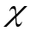 – coefficient of exponential smoothing. That is for the forecast the last point of a trend and counting of TS undertakes and then their weight combination will give us the forecast of the following point.
If smoothing of data happened by any other method then for smoothed trend you need to first estimate some regression “fitting” model, and only then you can forecast it.
At the forecast on the basis of regression curve, linear and nonlinear, after creation of model of a trend in the form of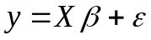, the forecast is made on the basis of the expression:
. (7.7)
This expression is presented for linear regression of an order k, but similar expressions of the forecast can be received from (7.7) by substitution instead of degree dependences of the corresponding nonlinear functions which describe behavior of this tendency within selection of a time series.
Strangely enough, but to predict a trend is very easy, in case of its description on the basis of regression analysis. Here only any forecast is not absolutely reliable therefore when forecasting a trend it is only not enough to describe its future counting, it is still necessary to evaluate borders in which it will be reliable.
The concept of a confidence interval of the forecast is exactly for this purpose. The confidence interval always defines two borders – upper and lower. In the turned-out “corridor” there is an estimated forecast. This forecast (being a stochastic variable) does not overstep the bounds of the confidential interval with the set reliability called -% limit.
Let the forecast of a trend be under construction on the basis of its regression model 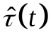. Borders of a confidence interval are described by expressions:
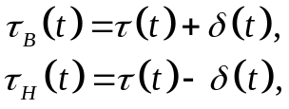 (7.8)
where 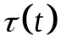 – forecast estimation of trend, 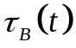 – upper confidence bound, 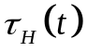 – lower confidence bound.
Then we are interested in the assessment of 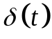. Depending on the value of an order of a polynomial trend, calculation will change. Let's consider two basic cases: linear trend and square trend.
For a linear trend, the forecast at the step l is:
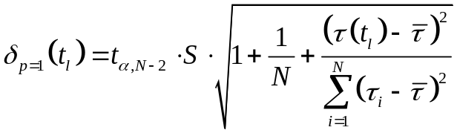 (7.9)
where 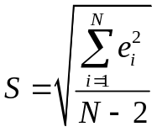, 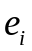 – residual data or row of errors, the difference between the initial time series and its model, 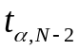 – the t-Student distribution quantile for a confidence probability with degrees of freedom 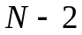 . Quantile value is found according to tables, or by means of special functions of mathematical and other estimated packets.
For a quadratic trend, the forecast at the step l is:
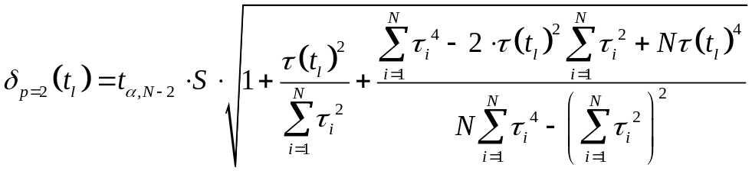 (7.10)
For higher degrees these formulas will expand more and more therefore we do not bring them here. For degrees of polynomials of an order more than 2 use table calculated values, or use specialized program functions, or 1/2 order estimates.
If the constructed forecast model is adequate, then with probability α it is possible to claim that when preserving of the developed patterns of development of a tendency, the forecast gets in a confidential interval.

Part 4. Estimated accuracy and quality of forecast
It is always important to evaluate the received forecasts for the accuracy and reliability as any forecast is never absolutely reliable. As an empirical measure of forecast accuracy serves the value of its error which defines a difference between forecast and actual value of observations for time series. This approach works only in two cases: values of the predicted observations are already observed, and it is possible to compare the received results to them; or at once the retrospective forecast is already under reconstruction. The retrospective forecast is calculated for observations of TS with a time frame for which there are already actual values. That is the retrospective forecast never goes beyond time frames on which observations of analyzed TS are set. Such forecast becomes for the purpose of verification of the scheme of forecasting.
At the retrospective forecast part of an initial row (about 2/3) is selected for the analysis and creation of predictive models. The rest (about 1/3) then is used for assessment of errors of the retrospective forecast. Similarly the mechanism of training of neural networks works – a part of selection goes for training, and a part – for validation.
Any indicators of assessment of forecast accuracy are divided into three groups:
- Analytical indicators of forecast accuracy;
- Comparative indicators of forecast accuracy;
- Qualitative indicators of forecast accuracy.
Let's consider each of them in more detail.

4.1. Analytical indicators of accuracy
Analytical accuracy of the forecast calculates forecast error quantity. Forecast errors can be calculated on absolute value, or on relative value.
The absolute forecast error 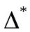 is calculated as:
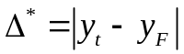 (7.11)
where 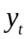 – the actual value of observation, 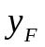 – forecasted value of observation.
The relative forecast error 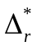 can be defined as the division of the absolute error (7.11) by actual value of observation :
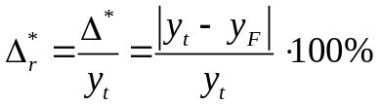, (7.12)
or by forecasted value:
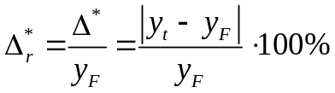. (7.13)
Absolute and relative forecast errors are a primary assessment of accuracy as, in fact, are an assessment of the point forecast. Overall accuracy of the forecast model will not be evaluated with these expressions.
Therefore in practice sometimes are used not the quantity errors, but quality coefficient of the forecast which shows a ratio between number of the matched observations and total number of the predicted observations M:
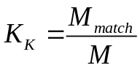 (7.14)
This indicator has an essential shortcoming: that in a formula (7.14) what we need to consider the matched observation? Any forecast point of data will not be matched to the actual value with 100% accuracy. From here it is necessary to define in addition some limit of proximity of the actual counting and forecast to consider them matched. It is clear, that the concept of coincidence is more widely treated, the coefficient of qualities will be better, that is the indicator is rather subjective.
Much better the general accuracy figure of the forecast for M points are values of a mean value of forecast accuracy and mean error of the forecast. The first indicator is calculated by formula (where 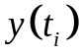 - actual observations, 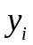 - forecasted observations):
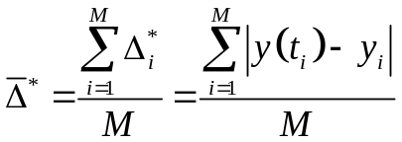 (7.15)
And the second – by formula:
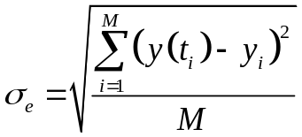 (7.16)
Both of these errors are integral (that is generalizing) forecast accuracy figures, but have also common fault – their dependence on the scale of measurement of observation levels.
Therefore it is more often not to put absolute values into practice, but the relative indicator called an average error of approximation which is expressed as a percentage and is calculated as:
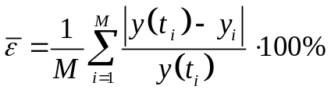. (7.17)
This indicator is usually interpreted as follows: if 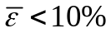, then the accuracy is high, if 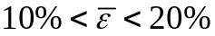, then the accuracy is good, if 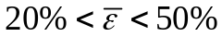, then the accuracy is satisfactory, if 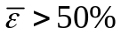 then the accuracy is not satisfactory (simply, bad).

4.2. Comparative and qualitative accuracy indicators
As a quality of a comparative accuracy the correlation coefficient between forecast and actual values of observations is used. It turns out that then the comparative indicator is calculated by a formula:
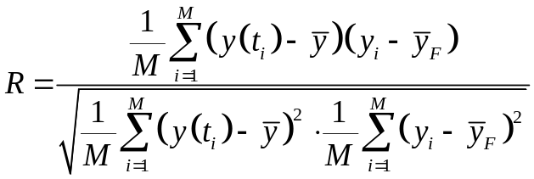, (7.18)
Using this coefficient in forecast accuracy assessment, it is necessary to remember that coefficient of pair correlation (7.18), owing to the entity, reflects a linear ratio of the correlated values and characterizes only interrelation between a number of the actual counting and a number of forecast counting. Even if correlation coefficient is R=1, then it does not mean coincidence actual and projections yet, and TS demonstrates only the existence of linear dependence between forecast and actual observations.
Other accuracy indicators are called the misfit coefficients that were introduced by G. Taylor. There are three of its modifications. The first modification:

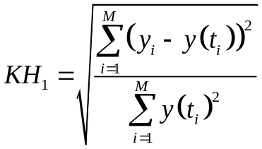, (7.19)
for which: if 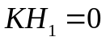, there is the exact fit between actual and forecasted observations; if 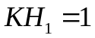, there is the accuracy of the simplest mean extrapolation; if 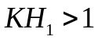, there is the accuracy worse, than the forecast based on constant mean value.

The second modification is estimated as:

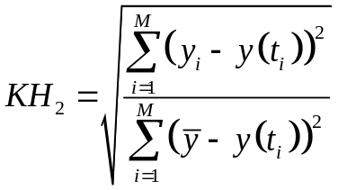, (7.20)
This is the ratio between the forecast SMSE and the variance estimation on the forecast interval.
At last, the third modification is estimated as:

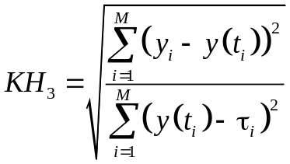. (7.21)
This coefficient is the ratio between the forecast SMSE and the linear trend forecast SMSE on the forecast interval. Overall, qualitative indicators show how good or bad the constructed forecast compared to:
КН₁ – constant mean value forecast;
КН₂ – time series variance estimation;
КН₃ – linear trend extrapolation;

References

1. Chris Chatfield. Time-Series Forecasting. — Chapman and Hall/CRC; 1st ed. — 2000. — 280 p. ISBN 978-1584880639
2. Box G., Jenkins G. Time Series Analysis: Forecasting and Control. — 4th ed. Wiley. — 2008. — 784 p.

